Genogram Poster
Craig Eben

For this assignment you need to make a poster size genogram of your family. Please make sure you put your name on the back of the poster. If one side of your family has more than 14 people, then you only need to complete the genogram of one side. Please use the key below to help you with the genogram. The genogram should start with your grandparents and go up to your youngest sibling/self. You will also be graded on creativity, so make sure you use pictures or other decorations. If you use pictures, realize you will not be getting them back. Therefore, they should be either photocopied or duplicates.
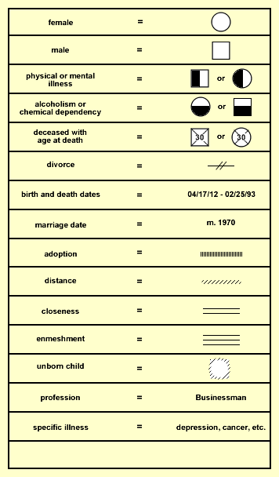
You can use more detail of symbols if you like; however, it is not required.

