Topic: Sleep deprivation
Abstract
- Introduction
  - 2 topic sentences minimum
    - It is becoming increasing alarming how sleep deprivation is affecting college students. Sleep deprivation is affecting college students because they are working and going to school.
  - Your problem
    - Are working college students sleep deprived?
  - 2 sources minimum
    - 2 transition sentences minimum
      - College students need to pay for their, often large, student loans. As society has changed, students have needed to work and attend college at the same time. Because of this, researchers have sought to understand how this effects student sleeping.
    - Direct quote from the source
      - As Smith states: “it is more common that college students are getting less than the recommended amount of sleep per night (Page 12.)"
    - 2 sentences minimum explaining how this relates back to your topic
      - College students having to work in order to pay for school directly effects their classroom performance. When people do not receive the recommended hours of sleep, they become at risk to negative effects associated with sleep deprivation. The consequences of sleep deprivation and daytime sleepiness are especially problematic to college students and can result in lower grade point averages. As a result, this study seeks to understand how this lack of sleep affects student’s GPA.
  - Hypothesis with because
    - Sleep deprivation impacts college student’s ability to perform well because it inhibits their ability to concentrate in multiple tasks.
- Method
  - Participants
    - College students ranging from 18-22 years of age. NJ state colleges and universities will be the location of the participant pool. Experimental group participants will work at least 20 hours a week. However, all participants will be required to maintain at least 12 credits in the semester.
  - Design
    - Control Group-Do not work
    - Experimental Group-Work at least 20 hours
    - IV-20 hours worked
    - DV (measure)-Hours slept
This experiment consists of two main groups. One group is consisting of individuals who work a minimum of 20 hours a week acting as the experimental group. The other group of individuals are not working at all and are acting as the control group. The experiment is dependent on the number of hours one is working and the result of these hours on their hours of sleep.
  - Material
    - This experiment requires a computerized survey that can be sent via email to all participants. All participants need working access to either a computer or phone with internet in order to access the survey and submit it back to the administrator. Results will be analyzed using Microsoft office excel. Participants will utilize a Fitbit to measure their hours of sleep.
  - Procedure
    - On the first day of the experiment, participants will be given a Fitbit, which they will always have to wear. They will also be provided with a notebook, where they will have to keep track of the worked hours during the semester. Data will need to be uploaded each morning to send to the experimenter. At the end of the experiment, researchers will collect Fitbits and journals from participants and will download the data of their slept hours during the experiment. This information will be documented in a excel sheet and compared against the two group’s results.
- Results
  - Nine out of ten participants in the Experimental group had less sleep on average then the control group. The Control group slept approximately 8 hours every night; however, the Experimental group slept for 6 hours. The one participant in the Experimental group that slept more, on average, did not have many other outside obligations.
- Discussion
  - Although working up to 20 hours a week could help students pay for college expenses, the experimenter has deduced working and attending classes can negatively affect sleep. The experimental results demonstrated college students who work 20 hours a week suffer from lack of sleep, which can create problems regarding a student’s academic career. Results of the study aligned with Smith (2020), as this study shows the students are getting less sleep than 7 hours per night. Studying the participants for the entire semester would yield better results as more data can be collected. Students will sleep better/worse at different points of the semester or year. Future research could explore college students who work 40 or more hours a week and how they manage sleep and study. Also, looking at eating habits and the types of food consumed can lead to better sleep at night. Student's sleep schedules have a deep impact on academic success and quality of life; it is essential students maintain a healthy balance of sleep, school, and other activities to develop into their best selves.
- References
  - Follow APA format
- Appendix
  - Graph
  - 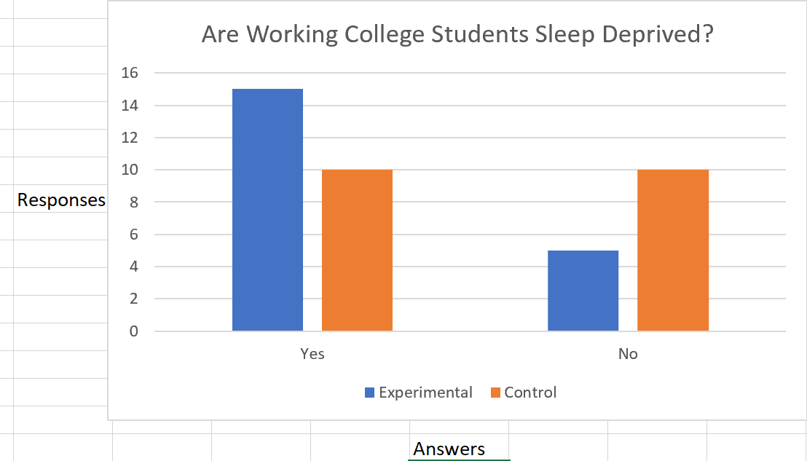
  - Survey?
  - Other items needing to be shared to replicate experiment

